Technical FAQs

GoControl Smart Doorbell Camera

This notice applies to the following products:
Model | Description
GC-DBC-1 | GoControl Smart Doorbell Camera

Abbreviations used in this document:
DBC = Smart Doorbell Camera
LED = Light Emitting Diode
PIR = Passive Infrared sensor

Accounts

Q: How many accounts may be setup with the DBC?
The doorbell camera supports up to four accounts, each with a different e-mail address. Note, an account may only be logged into one device at a time. If you use the ame account to login on different devices, one account will be logged off. So if you want to use a tablet and smartphone at the same time, use different e-mail addresses to establish two separate accounts.

Q: Do I need to be on the same WiFi network to invite another user?
You do not have to be on the same WiFi network to invite a user to connect to your Doorbell Camera.

Q: Can I use special characters in the Passwords?

Doorbell Camera and MyDoorbell app passwords:

The DBC and MyDoorbell app passwords can only support alpha-numeric character and the eight special characters: ! @ # $ % ^ & *
- WiFi Password
The Doorbell Camera may not connect to your home WiFi network when the DBC has firmware version 21 and the WiFi password has special characters.
Solution: Remove the special characters from your WiFi password, and then connect the Doorbell Camera to your home network so it can perform an auto-firmware update. After the DBC has performed a firmware update, then update your router WiFi password again to include the special characters. At this point you have to re-connect the DBC to your home network by holding down the doorbell camera button for 15 seconds to enter discovery mode. In discovery mode, the DBC LED’s flash red/green. Then use the MyDoorbell app to connect the DBC to the WiFi network.

Q: What is the Maximum Number of Users & Doorbell Cameras?
Please note one registered user can have two doorbell cameras attached to the account.
One Doorbell Camera can be linked up to four user accounts.

Doorbell Camera Limitations

Q: Does the Doorbell Camera support Wide Dynamic Range (WDR)?
The Doorbell Camera does not support WDR. However, the imaging capabilities are designed to provide superb video quality when a person is standing in front of the DBC, either in day or night. If you need to make adjustments to the video quality settings, then use the video adjustment features in the MyDoorbell app.

SmartPhone Limitations

Q: Is there a limitation with Nexus Smartphones?
Nexus 6 and Nexus 6P smartphones have an audio cancellation issue. When a person speaks to the Doorbell Camera he will hear his echo a second later. This is because the Nexus smartphones have a known issue where the speaker of the smartphone feeds into the smartphone microphone. Normally smartphones have an audio cancellation to avoid this. The Nexus smartphones do not cancel the audio effectively.

Q: Is there an issue with Android Power Management?
Some Android phones (i.e. Asus Zenfone 2) have a built in Power Management settings that deny the Auto-launch of selected apps to save battery life. If the MyDoorbell Camera app is in this list, then MyDoorbell notifications will be affected. You may not receive any notifications until the MyDoorbell app is removed from the list.

Firmware Update

Q: Can you update Doorbell Camera firmware Over-the-Air (OTA)?
Yes. When there is a firmware update to the Doorbell Camera, you will see a firmware update notification in the app. Navigate in the app to begin the firmware update. During the firmware update process, it is important that power is not removed from the doorbell camera.

Q: What if the Firmware Update fails?
If the firmware update fails or encounters an issues during updating, the emergency firmware update will start. This will re-download firmware to the Doorbell Camera so that it can still operate.

App Specific Notes (GoControl MyDoorbell)

Q: Are there any limitation with the iOS App?
The GoControl MyDoorbell App does not support iOS 8.x. Please update to iOS 9.x. or higher.

Q: Are there any limitations with the Android App?
The Android version of the GoControl MyDoorbell app has two extra options.
1. Microphone volume:
There are different brands of Android Smartphone that may have different microphone functionality and affect the output volume of the doorbell camera. If user feels that output volume from doorbell camera is too loud or too soft, the User can adjust the microphone volume.
2. Enable Software AEC:
Some Android Smartphones don't support hardware echo cancellation function. The Enable Software AEC option will help to cancel the echo. We can’t guarantee the echo cancellation quality, it would depend on Smartphone mechanical design.

Q: How do multiple notifications work?
When the doorbell camera is configured with multiple users, upon a doorbell activation, all smartphones are notified that someone is at the door. When the doorbell call is answered, the notifications on the other smartphones will stop.
Q: How do I recover my forgotten Doorbell Camera Password?
In the System Settings menu of the MyDoorbell app, select your Doorbell Camera. Select Change Password, then Forgot password. You will receive instructions on contacting Technical Support to receive a password key to reset your password. This option is also available when trying to connect to the Doorbell Camera and selecting Forgot Password once connected to the Doorbell Camera.

Multiple logins for the same account

Q: Can I have multiple log-ins for the same account
The GoControl Smart Doorbell Camera does not support multiple logins using the same account at this time.

Q: What happens if I lose my Smartphone or I purchase a new Smartphone?
In the sad event your smart device is lost or stolen, on the new smartphone download the MyDoorbell app and select Forgot Password to change your account password. Follow the instructions to re-send your verification code to your email address. We advise to change your email password for security reasons. Use the verification code to create a new password for your Doorbell Camera account.
Once logged into your account, re-connect to the Doorbell Camera using the Discovery method. This is done by holding the Doorbell Camera button for 15 seconds so that the LED is flashing red/green. Please follow the steps to connect your Doorbell camera to your WiFi network.
Electronic Chime

Q: Is an Electronic Chime supported?
No. The Smart Doorbell Camera does not support Electronic Door chimes.

Multiple Mechanical Doorbell Chimes

Q: Are Multiple Mechanical Doorbell Chimes supported?
The Smart Doorbell Camera does not support multiple Mechanical Doorbell chimes. However, there is a WiFi Chime option offered as an accessory item.

Session Limits (Timeouts)

Q: What are the Session Time-limits?

Session Times
Maximum Ring Time (doorbell notification) | 15 to 90 seconds (programmable)
Maximum Talk Time | 3 minutes
Maximum Video Viewing Time | 3 minutes

Audio

Q: Is the audio Full-Duplex?
The doorbell camera is technically not full-duplex; since the audio is close to full duplex, we call it “Near Full-Duplex”. The Doorbell camera and the smartphone can have a normal conversation.

LED Rules
What are the LED indicators for the Doorbell Camera?
Status | LED
Powering Up | Solid Red
Discovery mode | Flashing Green/Red
Connecting to Cloud Server | Flashing Green (Fast)
Connected to Cloud Server | Solid Green
Session in progress | Flashing Green (Slow)
Not Connected to Network | Flashing Red (Slow)
Firmware update | Flashing Red (Fast)

Motion Detection

Q: What is the distance that PIR Detection supports?
PIR detection will detect a person at about 1-15 feet depending on the sensitivity setting from the doorbell camera. Temperature can affect the PIR sensitivity.

Q: Are there PIR Detection limitations?
When a PIR is detected, the doorbell camera will recognize this instance for 10 seconds before triggering another PIR. These are known as the event intervals, or time between recognizing the next event.

Q: Does the PIR work in all temperature ranges?
The operating temperature range for the PIR motion sensor is 14 to 140 degrees Fahrenheit (-10 to 60 degree Celsius). The operating temperature of the Doorbell camera actually supports -22 to 122 degrees Fahrenheit (-30 to 50 Celsius).

Network

Q: What WiFi Networks are supported?
The Smart Doorbell camera only supports 2.4 Ghz Wireless N and Wireless G networks. It does not support 5Ghz networks.

Q: What is the recommended Internet Upload Requirements?
For optimal Doorbell Camera performance, we recommend a 2Mbps upload speed, but only require a minimum of 500kbps. Performance may be affected when using lower bandwidth networks. The Doorbell Camera will automatically adjust to available bandwidth conditions, now that’s smart.
Q: I changed Wi-Fi networks, how do I re-sync the Doorbell Camera to the new Wi-Fi network?
Press and hold the Doorbell Camera button for 15 seconds till the LED blinks Red and Green. This means that it is in discovery mode (i.e. ready to connect to a Wi-Fi network). Proceed to setup the Doorbell Camera and select the new Wi-Fi network when prompted.

Power

Q: What is the Start-up time for the DBC?
The Smart Doorbell camera start-up (power-up) time is 30 seconds when not connected to a WiFi network. When connected to a WiFi network, the start-up (power-up) time can take up to one minute because of WiFi registration.

Q: What voltage / power is required to support the DBC?
The GoControl Doorbell Camera requires 15-20VAC power supply with at least 10VA. It does not support a 24VAC power supply.

Q: What does the Power Connection Diagram look like?

With Transformer and Chimebox
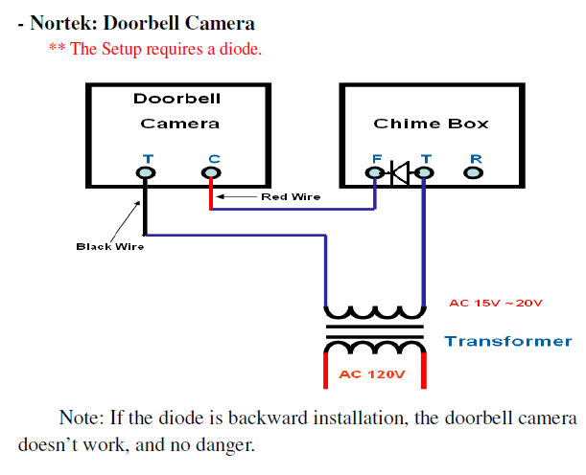

With AC Power Supply
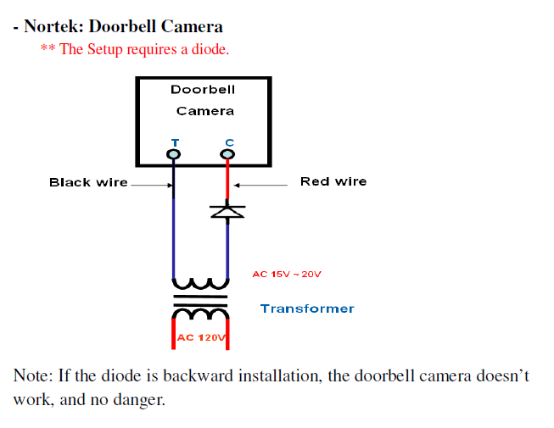

With DC Power Supply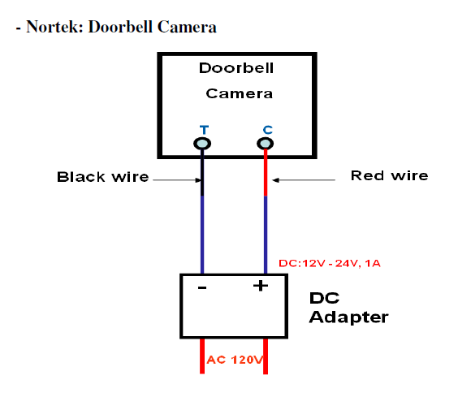

Submission History
2017-Jan-30 Submitted by Greg Stone and Ernesto Marin.
Keywords: GoControl Doorbell Camera, Technical FAQs

